

John R. Justice Student Loan Repayment Program Narrative

July 22, 2010

**Overview**

The Texas Higher Education Coordinating Board (THECB) has extensive experience administering student loans and student loan repayment programs whose purpose is to recruit and retain certain qualified professionals where there are shortages of those professionals. This experience will allow THECB to use key processes and resources already in place for those programs, while developing new procedures that are unique to the JRJ Grant Program.

The Texas District and County Attorneys Association (TDCAA) and the Task Force on Indigent Defense (TFID), which is administered within the Texas Office of Court Administration, will play a major role in program outreach and will provide input to THECB on program policy issues. The state’s funding allocation, less administrative costs, will be divided in half to distribute evenly the aggregate amount of funds disbursed for public defenders and for prosecutors who meet all eligibility requirements by the published deadline.

Public defenders and prosecutors will apply directly to THECB and applications will be ranked according to objective criteria developed by THECB, TDCAA, and TFID. THECB will communicate directly with program applicants; customer service representatives in THECB’s call center will respond to routine inquiries about the program.

**Distribution of Eligible Prosecutors**

Based on information obtained from the Texas District and County Attorneys Association (TDCAA), the THECB has determined that applicants eligible for prosecutor-designated funds could be employed by one of five different types of offices located throughout the state. Those offices are: district attorney, criminal district attorney, county attorney, city attorney, and attorney general. Together, those offices provide a pool of more than 3,000 criminal and/or juvenile prosecutors from which to draw applicants. The geographic and demographic distribution of applicants will generally mirror the population of the state at large, and it is possible that each of the 254 counties in Texas may have at least one eligible prosecutor applicant.

**Distribution of Eligible Public Defenders**

Each county determines how it will provide indigent defense services. Historically, most Texas counties have relied upon private appointed attorneys. However, since the creation of the Task Force on Indigent Defense in 2002, the number of public defender offices has grown from 7 to 16. One of these programs serves approximately 70 counties in West Texas and has offices in three counties. In addition to local public defender offices, the State of Texas operates the State Counsel for Offenders. This is a public defender office to represent prison inmates who commit new offenses while incarcerated and has locations in four counties - Montgomery, Walker, Lubbock and Travis. There are approximately 322 public defender positions in Texas representing potential applicants for public defender-designated funds. The highest concentrations of state and local government positions are in Dallas County and El Paso County. Appendix A includes the types of state and local government public defender offices, the populations for the counties where the offices are located, and the number of attorney positions in each office (totaling 190). There are also 132 attorneys working as federal public defenders in four districts of the state.

**Outreach**

The TDCAA and the TFID have formed a team that will coordinate all mass communications about the program using electronic means. The TDCAA maintains contact information for all prosecutors employed by district attorney, criminal district attorney, and county attorney offices in Texas. It has a proven ability to disseminate information and solicit input from the members of those offices by means of its website, a bi-monthly newsletter, an e-mail list-serve, a blast fax database, and through continuing legal education seminars that it conducts throughout the state. The TDCAA also maintains contact with the State Attorney General’s Office and the Texas Municipal Courts Education Center, which provides related services for city attorney personnel who may be eligible to apply under this program.

The TFID also maintains regular communications with the public defender community through its web site and e-mail list-serve. The TFID and TDCAA collaborated in sending an electronic survey to their constituents, gauging interest in the loan repayment program. Within a two-week period, 875 responses were received; this demonstrates the effectiveness of electronic communications for both organizations.

The electronic communications about the program will include references to a THECB web link to a program fact sheet, which will include an embedded link to the application documents. Additionally THECB will disseminate program information to the deans of Texas schools of law, to encourage graduating students to consider careers as public defenders and prosecutors. THECB will also send a news announcement to state media representatives.

**Program Eligibility Requirements**

Eligible Prosecutor

An eligible prosecutor must be continuously licensed to practice law as a full-time employee of a state or local unit of government in Texas, including tribal government, and:

1. Prosecute criminal or juvenile delinquency cases for the state or local unit of government and
2. Have been working in that capacity as a licensed attorney for at least twelve months.

Eligible Public Defender

An eligible public defender must have been working for at least twelve months as a licensed attorney providing legal representation to indigent persons in criminal or juvenile delinquency cases and must be continuously licensed to practice law as a full-time employee of:

1. a state or local unit of government (including tribal government) in Texas,
2. a nonprofit organization in Texas that is under contract with a state or local unit of government, or
3. a defender organization pursuant to Subsection (g) of Section 3006A of Title 18 of the U.S. Code, that provides representation to indigent persons in criminal or juvenile delinquency cases.

Eligible full-time employment includes the supervision and training of other persons providing the same services within the state or local unit of government. Substantially all of the attorney’s employment with a nonprofit organization must be devoted to providing legal representation to indigent persons in criminal or juvenile delinquency cases.

Disqualifying Condition

An otherwise eligible attorney will not be considered for participation in the program if the applicant is in default on the repayment of any federal student loan.

Eligible Loans

* Federal Stafford Loans
* Federal Graduate PLUS Loans
* Federal Consolidation Loans
* Federal Perkins Loans

Non-eligible Loans

* Federal Parent PLUS Loans
* Federal Consolidation Loans used to repay PLUS loans
* Any portion of Federal Consolidation Loans used to repay a spouse’s federal loans
* Non-federal student loans

**Application and Verification Process**

Candidates must ensure that the completed application, authorization for a tax return transcript request, and the BJA three-year Service Agreement have arrived at THECB by the published deadline. THECB plans to create an online application process that will be efficient and user-friendly, ensuring immediate entry of the application data. Documents requiring a signature will be delivered by mail, fax, or e-mail attachment (file in portable document format). These forms will, at the least, be posted as fill-able forms on the THECB web page for loan repayment programs, to be downloaded, completed, and delivered by the means indicated above. Applicants will be able to check the status of their applications online. The application will include an employment verification section requiring the employer to certify that the applicant meets the prescribed definitions of prosecutor or public defender and that the applicant has been employed in that capacity for at least 12 months. Follow-up calls or e-mails to employers will be conducted for a sampling of selected applicants. THECB will use the National Student Loan Data System (NSLDS) for verification of loan information. The highest ranked applications representing full expenditure of funds reserved for each group will be selected for verification of reported income and loan information.

THECB estimates that the application period will be November 1-December 31, so that the funds will be disbursed as taxable income for 2011. This will give candidates ample time to submit an application and will allow recipients time to plan for the added tax liability.

**Selection Process**

The application ranking process for public defenders and prosecutors will occur separately for each group. If funding for this program continues in future years, first priority will be assigned to renewal applicants. New applications will be ranked according to objective criteria established to identify those who are the least able to repay their student loans.

Geographic Distribution of Awards

The TDCAA has established eight regions within the State. THECB will sort prosecutor applications by geographic region and the ten eligible applicants within each region who are the “least able to pay” their loans will be selected for awards. Remaining eligible prosecutor applications will be ranked in order of inability to pay, without regard to geographic location, until all funds have been encumbered. Because of the uneven geographic distribution of public defender offices in Texas, it is not feasible to make allocations for public defenders based on geographic regions of the state.

Statutory Compliance Plan - Determination of “Least Ability to Pay”

Applicants are required to provide the amount reported for 2009 as Adjusted Gross Income on Line 37 of IRS Form 1040, as well as the total exemptions claimed on line 42; if a spouse filed a separate tax return, the information from both returns must be provided.

The data will be used to perform the following automated calculations:

1. Subtract the exemption amount from the reported AGI amount;
2. Divide the remaining AGI by the cost of living index for the location of the applicant’s residence;
3. Calculate the estimated annual aggregate loan payment amount (14% of the loan balance, based on an assumed 6% fixed interest rate and a 10 year repayment period);
4. Subtract the annual estimated student loan payment from the adjusted AGI.

The remaining AGI will be ranked in order of lowest to highest, and loan repayment awards will be disbursed to lenders on behalf of the selected applicants. Appendix B provides the cost of living index data for Texas and example calculations based on hypothetical scenarios are provided in Appendix D.

Cost of Living Adjustment – Methodology

THECB obtained 2009 cost of living index data for Texas from the Council for Community and Economic Research (C2ER), a nonprofit organization founded in 1961 as the American Chamber of Commerce Researchers Association (ACCRA). The ACCRA *Cost of Living Index* was developed to meet the need for a measure of living cost differentials among urban areas. The average for all participating areas, both metropolitan and non-metropolitan, equals 100, and each location’s composite index is read as a percentage of the average for all U.S. participating urban areas.  To determine a cost of living index for non-urban areas, THECB used the eight TDCAA geographic regions to calculate an average of the adjusted index values determined for the urban areas that lie within the regional boundaries. Appendix C is a map showing the regions.

**Loan Repayment Award Amounts**

Almost half of the 875 prosecutors and defenders responding to a recent TDCAA/TFID survey indicated that a loan repayment of $1,000 or less would make it worthwhile to apply. Uniform annual award amounts are more effective than varying amounts based on variable factors because they are easily communicated and understood state-wide, and allow for accurate renewal projections. Because the number of potential qualified prosecutors far exceeds the number of potential eligible public defenders, the annual loan repayment amounts will be as follows:

* $2,500 for qualifying prosecutors
* $5,000 for qualifying public defenders

No recipient shall receive more than the above amounts for the current grant period or an aggregate of more than $60,000 through the program. If full funding is awarded, these annual award amounts will allow THECB to disburse loan repayments to approximately 66 public defenders and approximately 132 prosecutors. THECB will disburse loan repayments to lenders and notify beneficiaries; in January of the following calendar year THECB will mail IRS Form 1099 MISC to beneficiaries and will meet IRS reporting requirements.

**Performance Measures and Reports**

All program data will be maintained electronically in a manner that allows for prompt, reliable queries for reports, including the total number of applications from prosecutors and public defenders, the total number of awards within each group, and the aggregate amount awarded within each group. In addition to all demographic and employment data, application receipt dates, loan repayment awards, and award dates will be retrievable. The number of working days elapsed between the published application deadline and the disbursement date will be computed. All documents related to the applications, including communications with applicants, will be maintained in THECB’s electronic imaging system. THECB will maintain a record of all outreach publications and communications. THECB will maintain time distribution reports to document administrative costs, and will adhere to requirements for quarterly financial and performance reports as well as semi-annual progress reports. The annual assessment of program effectiveness, in terms of recruitment and retention, will be based on surveys of prosecutor and public defender offices, and perhaps award recipients.

Breaches of Service Agreement

If THECB learns that a loan repayment recipient is no longer employed in the public defender or prosecutor position and therefore has failed to fulfill the service obligation, all documents on file for the participant will be forwarded to the Bureau of Justice Assistance. The file at THECB will be closed, with a notation that the attorney will not be eligible for participation in the program in the future.

**APPENDIX A**

|  |  |  |  |  |  |  |  |  |  |  |  |  |  |  |  |
| --- | --- | --- | --- | --- | --- | --- | --- | --- | --- | --- | --- | --- | --- | --- | --- |
|  | |  | |  | |  | |  | |  | |  | |  | |
|  | | **Texas State and Local Government Public Defender Offices** | | | | | | | | | | | |  | |
|  | | County | | Estimated | | Number of | | County | | Estimated | | Number of | |  | |
|  | | Location | | 2009 Population | | Attorneys | | Location | | 2009 Population | | Attorneys | |  | |
|  | | Bee | | 33,041 | | 3 | | Kaufman | | 97,872 | | 2 | |  | |
|  | | Bexar | | 1,593,859 | | 6 | | Lubbock | | 263,675 | | 4 | |  | |
|  | | Bowie | | 93,295 | | 3 | | Midland | | 126,353 | | 1 | |  | |
|  | | Cameron | | 391,857 | | 2 | | Montgomery | | 425,999 | | 9 | |  | |
|  | | Colorado | | 21,725 | | 2 | | Potter | | 121,743 | | 1 | |  | |
|  | | Dallas | | 2,377,477 | | 66 | | Travis | | 956,901 | | 10 | |  | |
|  | | Dickens | | 2,656 | | 3 | | Walker | | 64,239 | | 17 | |  | |
|  | | El Paso | | 749,721 | | 32 | | Webb | | 239,992 | | 15 | |  | |
|  | | Fort Bend | | 523,339 | | 2 | | Wichita | | 129,719 | | 6 | |  | |
|  | | Hidalgo | | 725,978 | | 6 | | Willacy | | 21,037 | | 2 | |  | |

|  |  |  |  |  |  |  |  |
| --- | --- | --- | --- | --- | --- | --- | --- |
| **Federal Public Defenders in Texas** | | | | | | | |
| District | City | County | Number of Attorneys | District | City | County | Number of Attorneys |
| Eastern | Tyler | Tyler | 3 | Northern | Dallas | Dallas | 10 |
|  | Beaumont | Jefferson | 3 |  | Ft. Worth | Tarrant | 4 |
|  | Frisco | Collin/Denton | 2 |  | Lubbock | Lubbock | 3.5 |
|  | Sherman | Grayson | 1 |  | Amarillo | Randall | 1 |
| Western | San Antonio | Bexar | 11 | Southern | Houston | Harris | 14 |
|  | El Paso | El Paso | 21 |  | Brownsville | Cameron | 9 |
|  | Del Rio | Val Verde | 10 |  | Corpus Christi | Nueces | 5 |
|  | Austin | Travis | 3 |  | Laredo | Webb | 17 |
|  | Alpine | Brewster | 3 |  | McAllen | Hidalgo | 11 |

|  |  |  |  |  |
| --- | --- | --- | --- | --- |
| **APPENDIX B COST OF LIVING INDEX - 2009 ANNUAL AVERAGE DATA FOR TEXAS\*** | | | | |
| METRO AREA | REGION | COUNTY | COMPOSITE INDEX AS REPORTED BY C2ER JAN 2010 | REGIONAL AVERAGE |
|
| Amarillo | 1 | Potter | 89.6 | 89.1 |
| Lubbock | 1 | Lubbock | 88.6 |
| El Paso | 2 | El Paso | 89.7 | 90.6 |
| Midland | 2 | Midland | 91.4 |
| Odessa | 2 | Ector | 90.7 |
| Abilene | 3 | Taylor | 87.1 | 89.3 |
| San Angelo | 3 | Tom Green | 91.4 |
| Brownsville | 4 | Cameron | 87.4 | 88.2 |
| Harlingen | 4 | Cameron | 86.7 |
| Corpus Christi | 4 | Nueces | 91.6 |
| McAllen | 4 | Hidalgo | 87.2 |
| Lufkin | 5 | Angelina | 91.1 | 91.4 |
| Nacogdoches | 5 | Nacogdoches | 94.5 |
| Waco | 5 | McLennan | 88.2 |
| Beaumont | 5 | Jefferson | 96.1 |
| Brazoria County | 5 | Brazoria | 90.9 |
| Conroe | 5 | Montgomery | 89.5 |
| Houston | 5 | Harris | 89.3 |
| Dallas | 6 | Dallas | 92.1 | 91.6 |
| Plano | 6 | Collin | 94.4 |
| Palestine | 6 | Anderson | 90.5 |
| Paris | 6 | Lamar | 86.1 |
| Tyler | 6 | Smith | 94.8 |
| Arlington | 7 | Tarrant | 94.6 | 92.4 |
| Fort Worth | 7 | Tarrant | 90.7 |
| Weatherford | 7 | Parker | 93.3 |
| Wichita Falls | 7 | Wichita | 90.8 |
| Austin | 8 | Travis | 96.5 | 92.3 |
| Round Rock | 8 | Williamson | 92.3 |
| San Marcos | 8 | Hays | 88 |
| Temple | 8 | Bell | 89.7 |
| San Antonio | 8 | Bexar | 95 |

*From ACCRA - Cost of Living Index 2009 Annual Average Data for U.S.

**APPENDIX C -Map of Regions –** For Cost of Living Index Averages in Non-Urban Areas

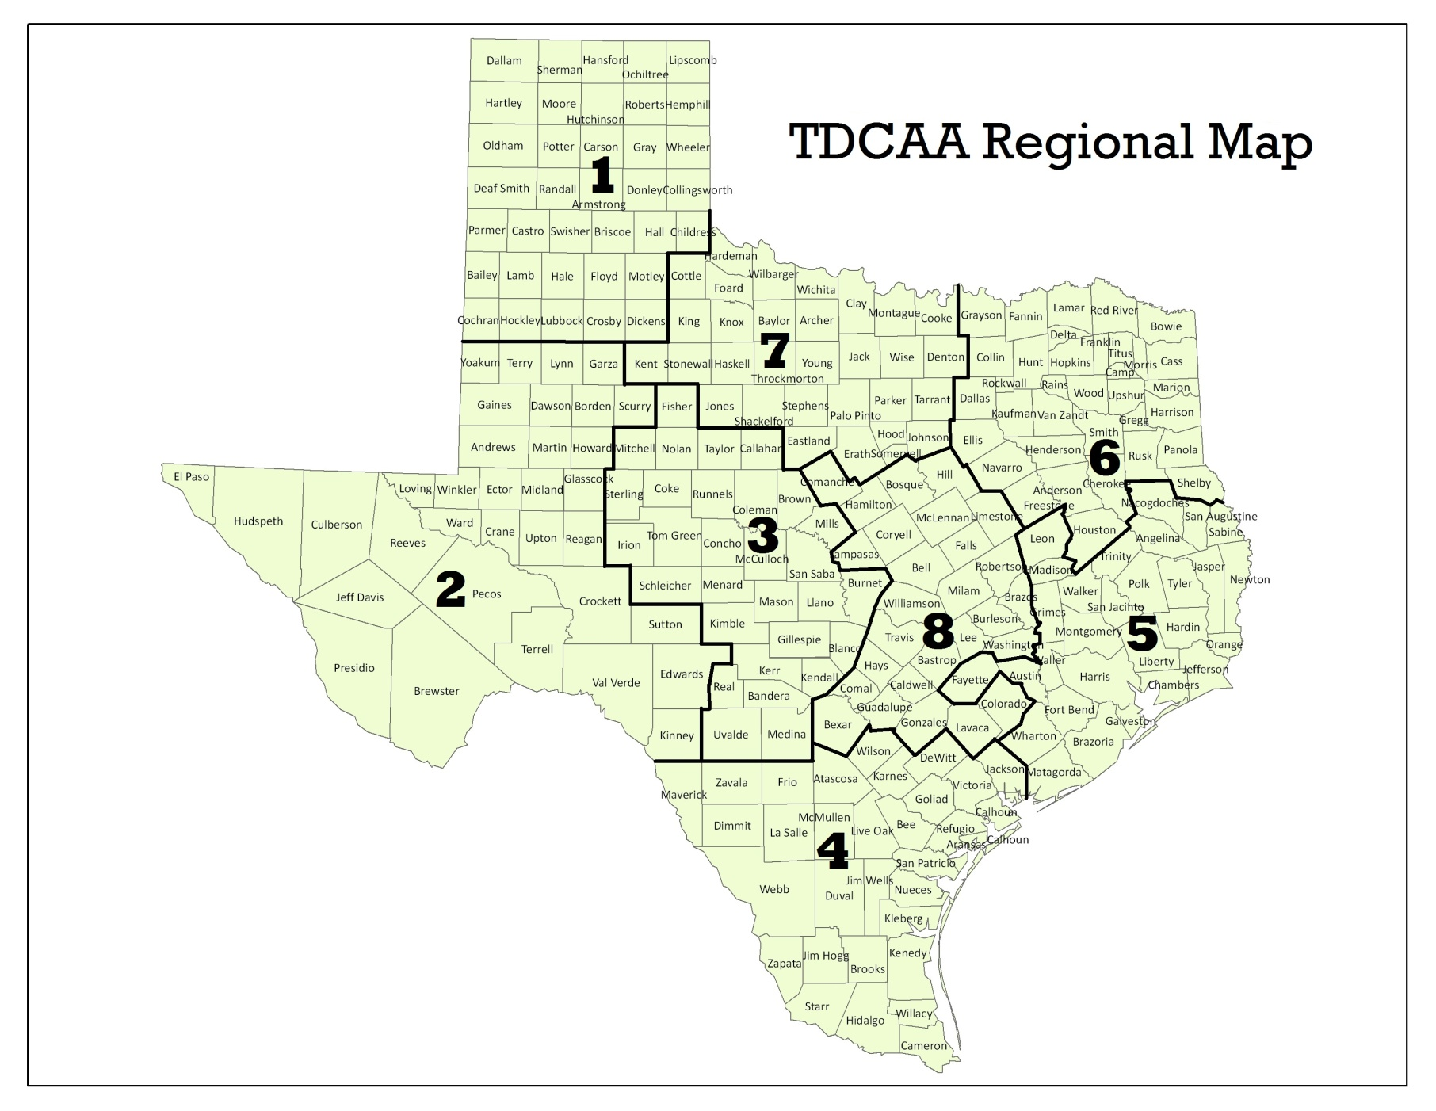

*TDCAA = Texas District and County Attorneys Association

**APPENDIX D** **Example "Ability to Pay" Calculations**

|  |  |  |  |  |  |  |  |  |  |  |  |  |
| --- | --- | --- | --- | --- | --- | --- | --- | --- | --- | --- | --- | --- |
| **1** | **2** | **3** | **4** | **5** | **6** | **7** | **8** | **9** | **10** | **11** | **12** | **13** |
| **Applicant** | **Urban Area or Region** | **Cost of Living Composite Index (U.S. Average)** | **Adjusted Gross Income (Form 1040 Line 37)** | **Exemptions (Form 1040 Line 42)** | **Remaining AGI** | **Remaining AGI Modified for Cost of Living** | **Total Balance of Eligible Federal Student Loans** | **Estimated Annual Student Loan Payment\*** | **2009 LRP Assistance Received but not Reported as Income** | **Remaining Estimated Annual SLP** | **Adjusted Remaining AGI Less Remaining Annual SLP** | **Ranking** |
|
| A | Beaumont | 96.1% | $63,490 | $7,300 | $56,190 | $58,470 | $54,000 | $7,560 | $0 | $7,560 | $50,910 | 4 |
| B | Brazoria | 90.9% | $64,230 | $3,650 | $60,580 | $66,645 | $78,290 | $10,961 | $0 | $10,961 | $55,684 | 7 |
| C | Conroe | 89.5% | $56,000 | $0 | $56,000 | $62,570 | $84,320 | $11,805 | $0 | $11,805 | $50,765 | 3 |
| D | Region 1 | 89.1% | $67,520 | $7,300 | $60,220 | $67,587 | $45,780 | $6,409 | $0 | $6,409 | $61,178 | 9 |
| E | San Antonio | 95% | $64,590 | $3,650 | $60,940 | $64,147 | $94,275 | $13,199 | $0 | $13,199 | $50,949 | 5 |
| F | Brownsville | 87.4% | $61,250 | $10,950 | $50,300 | $57,551 | $88,520 | $12,393 | $0 | $12,393 | $45,159 | 2 |
| G | Harlingen | 86.7% | $57,840 | $0 | $57,840 | $66,713 | $64,370 | $9,012 | $0 | $9,012 | $57,701 | 8 |
| H | Corpus Christi | 91.6% | $55,380 | $7,300 | $48,080 | $52,489 | $92,310 | $12,923 | $4,000 | $8,923 | $43,566 | 1 |
| I | McAllen | 87.2% | $59,708 | $3,650 | $56,058 | $64,287 | $62,890 | $8,805 | $0 | $8,805 | $55,482 | 6 |
|  |  |  |  |  |  |  |  |  |  |  |  |  |
| I. Subtract Exemptions in column 5 from Adjusted Gross Income in column 4 to determine Remaining AGI in column 6;  II. Divide the Remaining AGI in column 6 by the Cost of Living Composite Index % in column 3, to calculate Remaining AGI Modified for Cost of Living amount in column 7;  III. Multiply the Total Balance of Eligible Federal Student Loans in column 8 by 14%* to calculate an estimated annual aggregate student loan payment amount (column 9);  IV. Subtract any loan repayment assistance received during 2009 but not reported as taxable income (column 10) from the Estimated Annual SLP amount in column 9 to determine Remaining Estimated Annual SLP in column 11;  V. Subtract the Remaining Estimated Annual SLP in column 11 from the Remaining AGI in column 7 to determine amount in column 12 to be ranked from lowest to highest in column 13.  * An estimated annual payment amount of 14% of the eligible federal student loan balance is based on a standard 10 year repayment plan and an interest rate of 6%. | | | | | | | | | | | | |

**Advisory Group – John R. Justice Loan Repayment Program of Texas**

* Rob Kepple, Texas District and County Attorneys Association
* Shannon Edmonds, Texas District and County Attorneys Association
* Jim Bethke, Task Force on Indigent Defense
* Wesley Shackelford, Task Force on Indigent Defense
* Kammi Contreras, Texas Higher Education Coordinating Board staff
* Lesa Moller, Texas Higher Education Coordinating Board staff